Exocet missiles
Exo-Delta
This excellent small missile is widely used by French, Israeli and several European armed forces. Lightweight enough to be shoulder-fired, it is common as well as a vehicle-launched missile.
The missile is reputed to be very difficult to detect, even by modern electro-optical sensors, partly due to its small size, and also because of the absence of any smoke trail, a usual and tell-tale feature of any other current missile. A high speed and the innovative, highly agile, "PIF-PAF" vectoring thruster ensures high kill probability.
Exo-Delta is available in SRAM "Short Range Anti-air Missiles", ATAM "Anti-Tank Advanced Missile", ARAD "Anti-RADiations", AXE "Anti-structures high-eXplosivE" variants, and FLAM "Fire-setting Light Attack Missile" variants.
An -ER extended range vehicle-launched version is also available.
Like all French armed forces ammunitions, Exo-Delta missiles fully comply with MURAT ("Munitions à Risque Atténué") insensitive munition standards.
MURAT ammunition does not ignite by proximity effect (another munition detonating nearby), when fired upon (including heavy weapon fire of laser weapons) or engulfed by fire (including fires of a paranormal nature). Raise target numbers by +8 or give 8 dice for resisting effects (whichever is most appropriate) against any firesetting hazard and/or attempt.
Exo-Delta "Short Range anti-Air Missile" SRAM
SRAM is a highly agile anti-aircraft missile, designed to be used as a SAM by ground troops or as an AAM by aircraft.
Intelligence | Signature | Damage | Min Range | Max Range | Handling | Speed | Initiative
5 | 12 | 14D | 50 m | 5 km | 2 * | 5,000 m/turn | 5+3D6 *
Treat as anti-vehicle capable. Do not reduce damage level when fired against vehicle.
Reduce damage to 8D against target other than aircraft.
If the weapon sucessfully "ram" the aircraft (use vehicle combat rules), negate ALL armor. Otherwise, full armor rating apply. Note that the missile will explode even if it does not collide the target (due to its laser fuze proximity sensor).
* PIF-PAF vectoring thruster. CIWS systems trying to intercept the missile raise their target numbers by +2.
Missile costs 10,000¥ and weights 5kg. Needs .5 CF if fitted in a vehicle.
Availability (16/18days) and Street Index (5+) are indicative only and subject to GM's dicretion.
This is SOTA military-grade restricted hardware and should be pretty difficult to obtain.
Exo-Delta "Anti-Tank Advanced Missile" ATAM
ATAM is an anti-vehicle missile, with PIF-PAF high agility thrusters and triple warhead againsty ERA and ablative armor.
Intelligence | Signature | Damage | Min Range | Max Range | Handling | Speed | Initiative
5 | 12 | 16D | 20 m | 5 km | 2 * | 5,000 m/turn | 5+3D6 *
Direct hit does 16D. Do not reduce damage level when fired against vehicles. Use only half armor rating.
Triple-HEAT charge negates any effect by ERA (Enhanced Reactive Armor), regardless of level.
Blast damage is 16D with -8/meter damage reduction.
* PIF-PAF vectoring thruster. CIWS systems trying to intercept the missile raise their target numbers by +2.
Missile costs 10,000¥ and weights 5kg. Needs .5 CF if fitted in a vehicle.
Availability (16/18days) and Street Index (5+) are indicative only and subject to GM's dicretion.
This is SOTA military-grade restricted hardware and should be pretty difficult to obtain.
Exo-Delta "Anti-Radiation Assured Destruction" ARAD
ARAD targets active sensors (particularly radars) and ECM. Its fragmentation warhead guarantees 100% mission kill!
Intelligence | Signature | Damage | Min Range | Max Range | Handling | Speed | Initiative
5 | 12 | 16D | 50 m | 5 km | 2 * | 5,000 m/turn | 5+3D6 *
ARAD uses special targeting rules. Target number is 12 divided by target's highest flux rating (minimum 1).
Direct hit does 16D to target, treat as anti-vehicle. Use half armor rating, and do not reduce damage level against vehicle.
In addition to direct impact damage, Fragmentation effect does 16D damage with –1/meter damage reduction around impact area. Use flechette rules (double Impact armor).
Note that Fragmentation effect will destroy any sensitive equipment in the area (antenna, sensors, electronic components) and will incapacitate surrounding personnel.
* PIF-PAF vectoring thruster. CIWS systems trying to intercept the missile raise their target numbers by +2.
Missile costs 10,000¥ and weights 5kg. Needs .5 CF if fitted in a vehicle.
Availability (16/18days) and Street Index (5+) are indicative only and subject to GM's dicretion.
This is SOTA military-grade restricted hardware and should be pretty difficult to obtain.
Exo-Delta "Anti-structure high-eXplosivE" AXE
AXE is your basic HE missile, useful against buildings, bunkers and such.
Intelligence | Signature | Damage | Min Range | Max Range | Handling | Speed | Initiative
3 | 12 | 16D | 50 m | 5 km | 4 | 1,000 m/turn | 5+2D6
AXE does 16D damage on a direct hit, and damage level is reduced per -1 / 2 meters. Warhead is not anti-vehicle, but use only half barrier rating when breaching walls and such.
Missile costs 5,000¥ and weights 5kg. Needs .5 CF if fitted in a vehicle.
Availability (16/18days) and Street Index (5+) are indicative only and subject to GM's dicretion.
This is SOTA military-grade restricted hardware and should be pretty difficult to obtain.
Exo-Delta "Fire-setting Light Attack Missile" FLAM
FLAM is a dual-warhead missile used against dismounted infantry.
Intelligence | Signature | Damage | Min Range | Max Range | Handling | Speed | Initiative
3 | 12 | 20M / 8L | 20 m | 5 km | 4 | 1,000 m/turn | 5+2D6
Initial warhead effect is double. A fragmentation effect does 16D (flechette rules) with -1/meter damage level reduction. Immediately after detonation, a thermite charge ignites, doing 20M (with -1/meter damage level reduction) fire damage (use half impact armor only. Hardened armor does not reduce damage level. Vehicle armor uses its full rating). All flammable material in the affected area ignites (this may include clothes, body armor, ammunition, and vehicle tires).
Thermite continues burning for 2D6 turns, doing 8L damage each turn (resisted with Body dice only). Half (remaining) impact armor can be used to help resist damage, but no Combat Pool dice. Thermite sticks to things and people, so getting away from the burning area does not prevent you from fire damage. Thermite spontaneously ignites in contact with air (oxygen), and may so re-ignite even after having been "extincted". People crazy enough to enter an already burning area will suffer the 8L burn damage for the duration of remaining turns.
Missile costs 5,000¥ and weights 5kg. Needs .5 CF if fitted in a vehicle.
Availability (16/18days) and Street Index (5+) are indicative only and subject to GM's dicretion.
This is SOTA military-grade restricted hardware and should be pretty difficult to obtain.
Exo-Delta "Extended Range" -ER vehicle variant
ER versions raise their maximum range to 15,000 meters. Available for any Exo-Delta variant listed above (SRAM-ER, ATAM-ER, ARAD-ER, AX-ER, FLAM-ER)
Missile weights 15 kg. Each missile costs 1.5x more than standard variant. Needs 1 CF if fitted inside a vehicle.
Exo-Delta -ER missiles cannot be shoulder-fired; these are vehicle missiles only.
Exo-Delta launchers
Matra and Exocet have cooperated to produce a specifically designed launcher able to match the performances of Exo-Delta missiles, called "CROTALE" (rattlesnake).
This launcher is not mandatory, however, and disposable Exo-Delta container/launcher tubes are available for 500¥ each.
Exocet-Matra
" CROTALE "
missile launcher
Exocet-Matra "Crotale" (rattlesnake) is a dedicated shoulder launcher for Exo-Delta missiles. It is able to fire all Exo-Delta variants, and can be used in closed spaces (including from inside vehicles) thanks to a special baffle in the rear, which helps reduce firing signature as well.
Special baffle adds +2 target number modifier for locating the firer.
The launcher features a Sagem Day/Night MIRIAM scope, with an attached Esprit industries Vauban-II targeting module.
Vauban-II targeting module raises missile Intelligence rating by 2 as long as the firer keeps target acquisition.
The launcher can be shoulder-fired, or fitted on a vehicle. Vehicle-mounted Crotale launchers can accept Exo-Delta-ER extended range missiles, but shoulder-fired launchers cannot.
Crotale launcher (including Miriam and Vauban systems) costs 30,000¥, and weights 3.5 kg.
Sagem MIRIAM
Module Infra-Rouge et Intensificateur pour Affut Missile
The name roughly translates as "infra-red and low-light module for missile launcher"
MIRIAM features variable image magnification 1-3, infra-red, low-light, anti-flash, and anti-laser coating. MIRIAM complies with ADVAT .328 protocols (use smartlink II bonuses when using standard combat rules).
MIRIAM costs 12,500¥ alone, weights 2 kg, and can be fitted on most existing missile launchers.

Aztechnology "Amardillo"
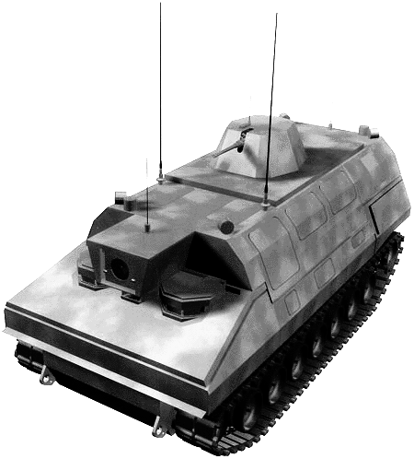
Armored Artillery Resupply Vehicle
The Amardillo is the standard armored resupply vehicle used by Aztlan forces, both in the nation and in the contested areas around the Yucatan. It uses the same highly advanced design as the Jaguar SPH, and is used to bring fuel and ammo to front-line and field artillery units under ennemy fire.
The vehicle follows the standard SPH layout, with three crewmembers in the front, with the vehicle commander, gunner, and driver. All have the standard displays and the vehicle is fully rigged. The crew compartment has cabin overpressurization in case of NBC warfare. APPS helps protect the crew from any accidents that should happen. The engine itself is sealed against any leaks or damage to the fuel tanks. Protection is given by standard composite armor, with options for Ablative or ERA armor. This is used extensively in the Yucatan area, with the additional armor stopping the numerous AVMs and ATGMs being fired from the guerrillas. Thermal baffles mounted on the engine area mitigate the vehicle's thermal signature, as well as having increased maneuverability. The vehicle is also fully amphibious as well.
The vehicle mounts a telescopic front boom, which is used for transfering supplies or refuelling under fire. The vehicle carry enough fuel and supplies to replenish a battery of four Jaguar howitzers.

The vehicle's defensive systems consist of electronics and a HMG. The Amardillo mounts military grade ECM for EW protection. Local protection is afforded by a small remote turret on top of the main turret that mounts a Heavy Machine Gun.
Handling | Speed | Accel | B/A | Sig | Autonav | Sensor | Cargo | Load | Cost
4/3 | 50 | 8 | 8/18 * | 6 | 4 | 0 | ** | ** | 4,091,700¥
* Level 12 Composite Armor
Chassis : SPH (Casemate)
Power plant : SPH
DP : 7,889; Mark-up factor : 5.0
Total CF : 248.5; load : 26,830 kg
Seating : 3 bucket seats
Access : 3 hatches
Fuel : Diesel (900 liters)
Economy : 0.5 km per liter
** Cargo : 160 CF available for 4x 80 rounds of ammunition, 72 CF for 3,600L fuel tanks.
** Load : 16,000 kg available for 4x 80 rounds of ammunition, 2,880 kg for 3,600L of fuel; 2,400 kg available for ERA / Ablative Armor.
Sensors :
- standard autopilot sensors (0)
- ECM : Military I (8)
Combat Electronics :
- Threat Warning System
- Navigation and Orientation Computer
- Communication master unit (Level 14) with satellite uplink and laser communication link
- Electronics ports (x2)
Other Features :
- Datajack Port (x3), Rigger Adaptation, APPS (x3), Level 3 Amphibious Package, EnviroSeal (gas), EnviroSeal (overpressurization) with 30 man hours life support, Internal Fire Extinguisher (rating 12 against fires), Smartlink II Integration kit, 2 integral large chaff/flare/smoke dischargers (12 rounds).
- Telescopic refueling/resupply boom.
- Improved Suspension***, Off-road Suspension***, Extra Large Vehicule Signature modifier (+200 CF, Sig -1)***, Stealth Design (2)***, RAM (1)***, Thermal Baffles 2***, Composite Armor Level 12***
- Provisions for Ablative Armor or Explosive Reactive Armor up to triple-layer ERA (2400 kg)***.
Armament :
- 1 stealthy [RAM (1) ***] small remote turret with anti-air capability, mounting an HMG with 1,500 belted rounds.
*** Already Factored In

ESPRIT industries
Caesar 155
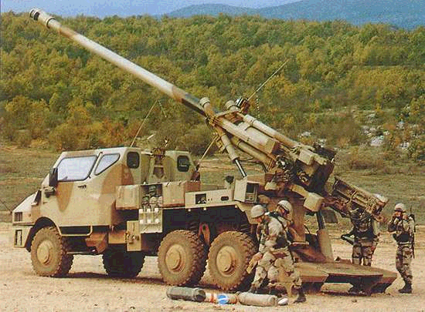
High-Mobility 155mm Field Howitzer

The CaESAr ("CAmion Equipé d'un Système d'ARtillerie") truck mounted artillery system is a 155mm/52 calibre self propelled gun developed by ESPRIT Industries of France. The advantage of Caesar over other similar platforms is that it is equipped with all the systems needed for independent operation : a cabin to protect the six man gun crew against shell fragments and small arms fire, an initial ammunition supply of 48 complete rounds and instrumentation for navigation, aiming, ballistic calculations and command aids. The system was specifically designed to meet the fire support requirements of rapid deployment forces.
Caesar is capable of using a wide range of ammunition for deployment against protected and unprotected targets, to create counter-mobility obstacles to block the manoeuvres of enemy armoured forces and to obscure or illuminate an area. A unit of eight Caesar self-propelled artillery vehicles can dispense, in less than one minute, more than one tonne of projectiles, 1,500 bomblets or smart anti-tank munitions on targets at ranges up to 40 km.
Caesar is equipped with a 155mm, 52 calibre barrel. The weapon has an automatic loading system, and can fire bursts up to 6 rounds in rapid fire. The gun can be set into and out of action in less than 1 minute. The weapon system configuration and the provision of hydraulic drives give a very short time, approximately 30 seconds, to take the Caesar out of battery, which is an important safety factor when there is the possibility of being targeted by hostile gun-locating radars.
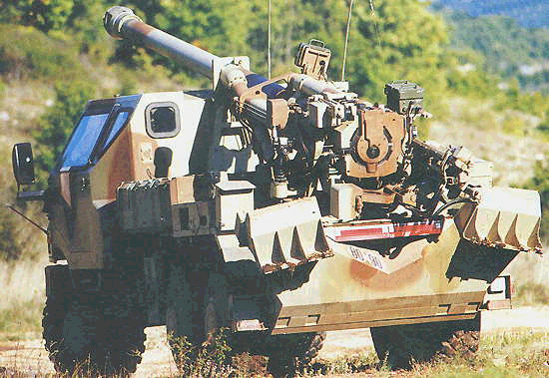
The all-terrain vehicle is an Eurotruck Unimog 6 x 6 series chassis. Caesar has an unrefuelled travel range of 600 kilometres and maximum speed of 120 kilometres per hour. A centralised ground pressure distribution system gives good cross country capability. Caesar is sea and air transportable without preparation. Including its crew and ready ammunition supply, Caesar can be carried in a single load of a C-260 Titan transporter. After driving out of the C-260 the time taken to be ready for operation is less than 2 minutes.

Handling | Speed | Accel | B/A | Sig | Autonav | Sensor | Cargo | Load | Cost
4/6 | 100 | 5 | 5/15 * | 5 | 4 | 8 (11) | 3 CF** | 285 kg** | 6,610,300¥
* Level 10 Composite Armor
Chassis : Medium transport
Power plant : Heavy transport
DP : 11549 ; Mark-up factor : 4.0
Total CF : 140 ; load : 11,500 kg
Seating : 3 bucket seats
Access : 2
Fuel : Diesel (200 liters)
Economy : 3 km per liter
** Cargo : + 24 CF available for 48 rounds of ammunition.
** Load : +2,400 kg available for 48 rounds of ammunition.
** Provisions for level 3 Ablative Armor or single-layer Explosive Reactive Armor (500kg)
Sensors :
- Military I (8)
- ECM : Security II (6)
- EECM : Military I (8)
Combat Electronics :
- Esprit Industries "VAUBAN-III" targeting assistance system
- Sony Battletac FDDM master unit
- Sagem SARA tactical computer
- Sagem ORIENT orientation system
- Philips Tacticom Communication master unit (Level 14)
- Electronic ports (x2)
- Matra DAMIEN missile approach warning and threat detection system
- Esprit Industries AM-56 decoy launcher (Level 4)
Other Features :
- Datajack Port (x3), Rigger "Black Box" Adaptation, APPS (x3), roll bars, Level 1 Amphibious Package, EnviroSeal (gas), EnviroSeal (overpressurization) with 60 man hours life support. Eurotruck "VarBar®" centralised ground pressure adaptation system, runflat dual-purpose tyres.
- Off-Road Suspension ***, Improved Suspension ***, Thermal Baffles 2 ***, RAM 1 ***. Composite Armor (Level 10) ***.
*** Already Factored In
Armament :
- Esprit Industries C-155 E3 155mm/52 barrel
with autoloader and 24 ready rounds with type I and II charges.
- 2x large flare/chaff/smoke dischagers (12 rounds)

